For Immediate Release

New DW Spectrum® IPVMS v3.0 is Now Available
Digital Watchdog’s Flagship Management Software is
Better than Ever with New Interface and Features
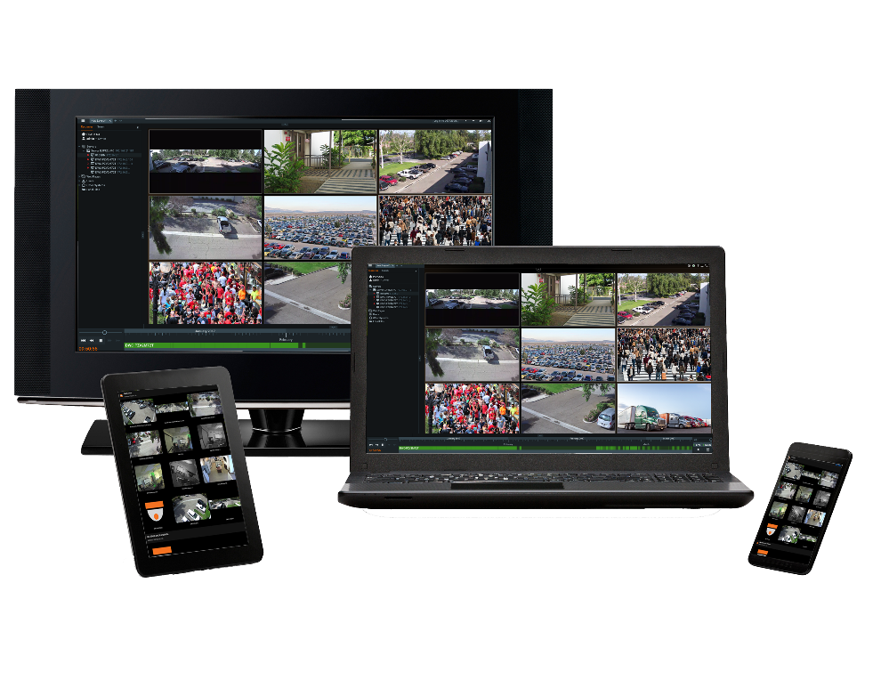
DW Spectrum® IPVMS v3.0 – Built for Users™

Cerritos, CA (August 3, 2017) – Digital Watchdog® (DW™), the industry leader in digital recorders, surveillance cameras and related management software, is proud to announce the release of the latest build of DW Spectrum® IPVMS. New version 3.0 takes a quantum leap forward in design and operability, delivering the most advanced capabilities while making the user interface (UI) simpler to master than ever.
DW Spectrum® v 3.0 has been built on a new platform, making it even more reliable and powerful than all versions that came before. The new platform includes a completely revamped user interface (UI), with a cleaner and simpler user experience, dynamic playback functions including an adjustable video buffer and an embedded browser that makes it possible to use other security management tools within the DW Spectrum® UI.
DW Spectrum® v3.0 introduces a beta version of the new DW® Cloud™ service. This valuable feature allows administrators to login to their servers from anywhere and easily invite and manage system users using only an e-mail address and password. DW® Cloud™ offers a secure and convenient alternative to complex port forwarding and intricate network configurations. Without the need for port forwarding, DW® Cloud™ offers easy and secure access to an unlimited number of networks and configurations from a convenient webpage.
DW® Cloud™ also allows admin users to easily create customized user roles. Admins can still assign and manage hundreds of users through the server interface, but DW® Cloud™ further simplifies the assignment of user permissions and recorder access. Using DW® Cloud™, administrators can manage hundreds of thousands of users and sites from a secure interface — anywhere, anytime.
“We have always said that DW Spectrum is ‘Built for Users’ and version 3.0 represents a renewed commitment to that pledge,” said Mark Espenschied, Director of Marketing, Digital Watchdog. “Administrators and users will discover new usability and convenience for user management, video management, live monitoring and the instant searching of recorded video.”
New Features in DW Spectrum® IPVMS Include:
- New Desktop Client UI and Framework. Newly revamped desktop client software for Windows®, Mac® and Ubuntu® Linux®.
- Custom User Role Management. Administrators can now create custom roles and share layouts and custom groups of users and hardware.
- New Windows Installer. Makes setup of local or cloud-connected systems as easy as possible.
- Upgraded Mapping Function. Users can overlay alarms and cameras on a map embded within the interface, for a more accurate and synchronized monitoring experience.
- New Server Storage Database. Increases performance of server archive management.
- View Archive from Deleted Cameras. Allows users to see archives for deleted cameras that still have footage in a storage archive.
- DW® Cloud™ (Beta). Connect your system to DW® Cloud™ to login and manage your systems from anywhere and share access to your system.
- View Web Pages in the Desktop Client. Users can add, view, and interact with URLs in the Desktop Client.

The DW Spectrum® IPVMS updates automatically in systems where previous versions are already installed. Click here to view the product’s page on our website or go to www.digital-watchdog.com and search for DW Spectrum.

Click here to download the full release notes, system requirements and manual update codes.
Click here to learn more about the software and download it for free.

ABOUT DIGITAL WATCHDOG
Digital Watchdog® (DW™) empowers our customers as the industry-leading single source of value-driven complete solutions for all video surveillance applications (HD over Coax™ / hybrid / IP enterprise), focusing on ease of use and ROI. DW™ products offer technologically-advanced features including multi-sensor HD cameras at real-time 30fps, Star-Light™ super low light technology, WDR, Smart DNR™ and Smart IR™. Complete IP megapixel surveillance solutions include single- and multi-sensor MEGApix® cameras and edge recording systems, Blackjack® NVRs and DW Spectrum® IPVMS for server, mobile and on-camera control. Complete HD over Coax™ surveillance solutions include single- and multi-sensor STAR-LIGHT™ HD over Coax™ cameras, VMAX® Universal HD over Coax™ DVRs and mobile management applications.
XXX
For Images or More Information:
Mark Espenschied
Director of Marketing
Digital Watchdog
marke@digital-watchdog.com
Toll Free: 866.446.3595 x283
www.digital-watchdog.com

